ISE 311 PROJECT- DETAILED DESCRIPTION AND DESIGN

ENTITIES, ATTRIBUTES, AND RELATIONS

A specific manufacturing company wants us to design their main factories database. Here’s the information that we gather:

* Employees are identified by an ID, and their names, phone numbers, gender, salary, and sales must be recorded.
* Customers are identified by an ID, and their name, mail must be recorded.
* Factories are identified by an ID, and their name, phone numberi location, and manufacturing target must be recorded.
* All manufactured products identified by an ID and their price, type, average quant and manufacturing duration must be recorded.
* Store ID, date, quant information about orders.
* Store ID, transportation type, and transportation cost information about shipping.
* Store ID, net price, target sales, demand information about sales.
* Sales made are shipped from factory to customers.
* All employees work in one specific factory.
* Products are produced in factories. Each product can produce in each factory.
* Factories can make sales. Factories sell products to customers.
* Employees took orders from customers.
* A factory can receive more than one order. At the same time, each order can be received by more than one factory.
* Each ordered product will be produced. Every manufactured product will also be sold.
* Every product sold will be shipped by the company.
* Each sale has its own unique shipping. Each shipment belongs to at least one sale.
* Each sales must have a sales ID and each order must have an order ID.
* Each employee can receive more than one order. Every order must be taken by an employee.
* A product can be ordered more than once. Only one product can be ordered per order. The product will be produced after each order.
* A different order number is assigned for each order. Only one type of product can be ordered in an order. If the customer wishes to order a different product, a different order number is assigned to him. The quantity of the order depends on the customer.

E/R DIAGRAM

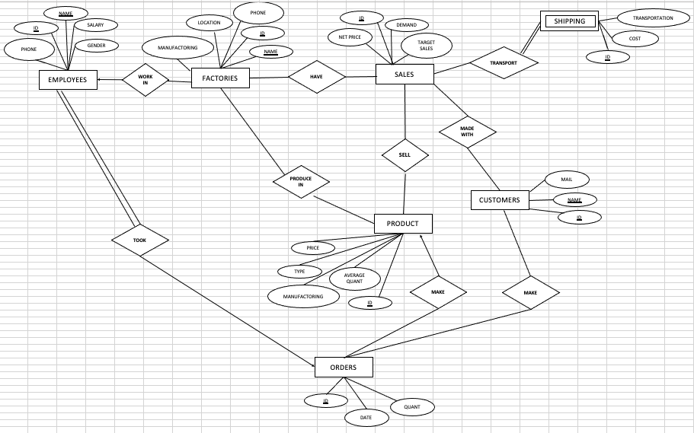

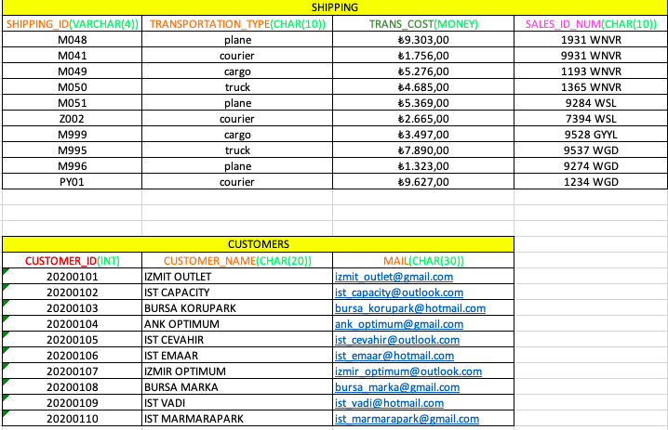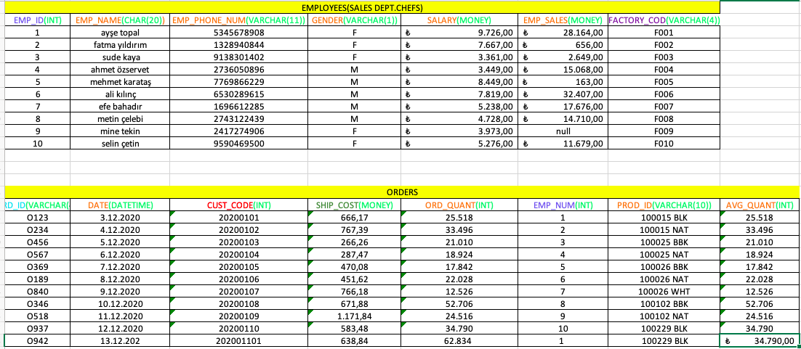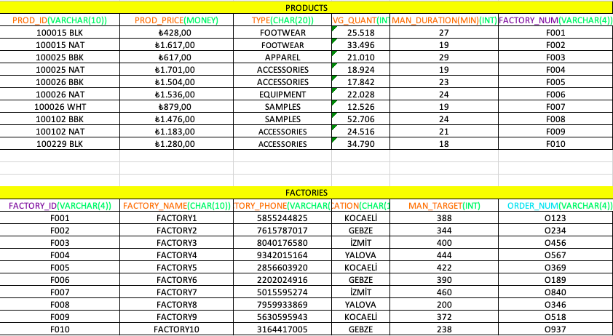TABLE STRUCTURES

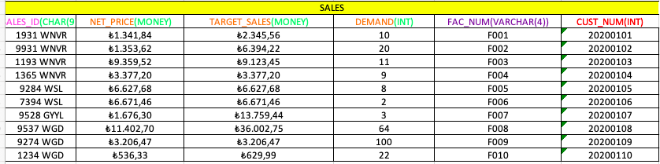

DATA TYPES

